ABC Medical Center

BUSINESS PLAN


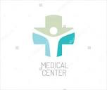
PO Box 15454 (P) 585-820-1451
1500 Elmwood Avenue (F) 585-820-3565
ROCHESTER, NY 14615 gerberal01@mail.buffalostate.edu

Table of Contents

Table of Contents …………............................................................................................. 2

Executive Summary ......................................................................................................3-4

General Company Description.......................................................................................5-6

Sample Job Description.................................................................................................7-8

Human Resources: Productivity/Schedules................................................................ 9-10

Labor Budget……......................................................................................................11-12

Marketing Plan……………………….………………………….…………………………13-17

EXECUTIVE SUMMARY

ABC Medical Center is an impressive, innovative area hospital located in the heart of Western New York residing in the Rochester area. It was founded by native resident, Isabella Rose, on the premise to provide a center that promotes one of the best healthcare facilities in the nation based on advanced technologies that is paramount in successful intervention and treatment with a focus on advocating prevention and stimulating educational awareness.
The food service department, named “Amy’s Eatery”, consists of a conventional/traditional system that involves centralized meal assembly. With this type of a food service system, all items on the menu are prepared in the kitchen on the premises it will be served. Patient meals will be delivered per tray-line, ready-made assembly. Additional meal services are provided for heart-healthy patients upon doctor request.
In order to service the needs of our internal and external customers/patients, we will employ 35 part-time and 3 full-time employees, serving 3 meals a day, 7 days a week to both patient’s and cafeteria customers. We will serve breakfast, lunch, and dinner which will be run in three shifts. The labor will consist of 11 kitchen staff, 2.5 dishwashers, 2.5 tray deliverer personnel, 2.5 cashiers, 2.5 cleaners, 2.5 chefs, 0.5 floaters, and 1 director. The monthly sales are projected at $98,952.00 with a monthly labor budget of $58,495.05.
Do to fluctuation in the economy, minimum wage increase, and rising costs, an adjustment of 3% decrease in labor will take place beginning in January 2019. After careful consideration, the adjustments made are to go to 32 part-time employees and 5 full-time employees which involves cutting one position and changing 2 part-time positions to full-time. The changes also involve reducing all part-time positions from 25 hours per week to 20 hours per week. With the reduction of labor hours, it allows for an increase in wages to be implemented across the board to meet the current salary demands of the Rochester geographical area. Overall, this adjustment brought us from 25 FTE’s to 21 FTE’s and reduced labor costs by $1,754.85 per month.
Upon budget proposal approval, it was requested that the food service department submit a marketing survey strategy to increase healthcare facility revenue. After careful consideration, it is decided that the foodservice department will create a new venture of portable good services. This entails a coffee café in the main lobby area during breakfast hours. It will be called, “Amy’s Coffee Café” and will offer healthy quality breakfast items and beverage options during the morning hours of 7AM - 11 AM. The food service department will average between 1-2% in revenue per month. No additional staffing will be required. We will utilize the morning kitchen staff employees. These goods will provide a convenient, quick, and easy alternative to grab a morning meal on one’s way to their destination. This venture will allow a service that offers consistent, convenient, and reliable menu times at reasonable pricing compared to other competitors.
The average sales per month is currently $98,952. We are looking to increase our sales by 1-2% , thus producing an increased revenue range of $989.52 - $1,979.04 per month.

GENERAL COMPANY DESCRIPTION:
FOOD SERVICE OVERVIEW

MISSION STATEMENT:

“The mission of ABC Medical Center is to provide patient-centered healthcare and wellness to anyone in and outside of our community with excellent service, benefits, and quality care. Our goal is to encourage, inspire, and promote an environment to achieve one’s full potential for a healthy lifespan in a caring, convenient, cost-effective, and accessible manner”

ABC Medical Center is centrally located in the heart of Rochester, New York. Our facility continuously stays abreast and maintains state-of-the-art technology to keep up with the changing demands of patient care and quality standards. In addition to having the capabilities of our area competitor hospitals, we are exclusive in the area at being a teaching hospital.
At ABC Medical Center, the Food Service Department’s “Amy’s Eatery” goal is to oversee the menu planning and service for breakfast, lunch, and dinner. We provide fresh, healthy, and nutritious meals to inpatients, hospital employees, families, and visitors. Our food service operation is conventional/traditional that involves centralized meal assembly. We supply food service to 333 beds on a weekly menu-cycle. We offer fresh fruit and salad bars, homemade soups and sandwiches, as well as traditional home-style, grill, deli, pizza, and dessert stations that encompass a variety of healthy local foods to our guests. When coming to Amy’s Eatery here at ABC Medical Center we provide essential nutrients to help support health and healing, encourage healthier food choices with nutritious options, and create a memorable dining experience with exceptional service.
To promote our service, we welcome and encourage staff and faculty employees, patient families and friends, outpatient customers, as well as external customers such as distributors and vendors. Our coffee café will offer a wide variety of goods such as assortments of freshly made whole grain muffins and bagels, oatmeal bowls, yogurt parfaits, wholesome breakfast bars, fresh fruit, a variety of breakfast sandwiches, juices, and gourmet coffees and teas. We have incorporated a “farm to market” philosophy that will provide fresh produce while encouraging community growth to our local agriculture. The hours of operation for Amy’s Coffee Café are 7:00 am - 11:00 am daily and the cafeteria is open daily from 9:00 am – 7 pm. Our portable coffee café will look to becoming a 24-hour service where we will promote loyalty cards, BOGO specials, quarterly health fairs, and various smaller versions of food stations throughout the hospital.
Some changes that we foresee here at ABC Medical Center are to increase awareness of prevention, early diagnosis, and alternative treatments through education and health and wellness programs. Long-term goals include but are not limited to a fitness center for staff and students as well as a library to be utilized by staff, students, and outside organizations in the healthcare world.
We believe with our strengths and core values of innovation, quality, flexibility, specialized expertise, and customer service, we are on the cutting edge of being one of the top facilities in the country.

SAMPLE JOB DESCRIPTION:
FOOD SERVICE WORKER

REPORTS TO:

Food Service Manager or designated area lead such as Kitchen Supervisor, Shift Manager, etc.

POSITION DETAILS:

Department: Food and Hospitality Services

Job Title: Food Service Worker

Position Number: K01234

Assignment Category: Regular, Full-Time

Job Type: Staff

Staff Work Months: 12

Percentage of Effort: 100

Pay Grade Level: 3

Salary: $10.40-$12.00/hour

Status: Non-Exempt

Job Description Summary: Performs as a general worker in job areas where assigned, including preparing, presenting, and serving of food and beverages in several food service environments, assisting in set-up and take-down of equipment, cashiering, transporting, dishwashing, cleaning of kitchen and dining areas, collection and sanitation of trash and recycling. Works as a team player. Attitude and appearance reflect company image. If you are passionate about nutrition and looking for a job in the food industry, food service work is a great way to get you started on your career path. Must be at least 18 years of age or older. Minimum of High School diploma or GED. One-year food service experience, preferred.

JOB DUTIES:

Key Accountability | Food Prep
Duty Statements | Set-up and take-down of equipment, such as; steam tables in home-style area, salad and fruit bars, beverage machines, soup bins, condiment counters, grill and deli areas. Prep and assist in preparing food for all food service stations. Clean work areas/stations and cafeteria tables and floors. Wrap, store, and date food in proper containers. Assist sous chef with prep work as needed upon request. Collect garbage and trays of tables. Replenish food stations throughout the day. Wash dishes and clean kitchen as specified.
Percentage of Time | 40%

Key Accountability | Clerk
Duty Statements | Inventory incoming produce and items required to maintain kitchen and cafeteria. Stock and maintain freezer and stockroom. Perform cashiering duties including counting drawer at beginning and end of shift. Test hot/cold food items that follow proper ServSafe sanitation regulations. Fill condiments, trays, silverware, plates, cups, and paper products throughout the day. Greet customers and assist as needed.
Percentage of Time | 35%

Key Accountability | Ambassador
Duty Statements | Transport food trays to patients. Collect food trays from patient rooms. Stock and maintain vending and beverage machines.
Percentage of Time | 25%

PERFORMANCE STANDARDS:

- Effective analytical and communication skills.
- Knowledge of basic computer skills.
- Operate POS system.
- Adhere to all safety policies/procedures/standards according to job duties.
- Lift/carry over 50 lbs.
- Stand for long periods of time.
- Adapt easily to cold and hot working environments.
- Multi-task and fill in were needed.
- Rotate to various stations on a weekly basis as requested by Food Service Manager.
- Work in a fast-pace environment.
- Display optimal customer service to both external and internal customers at all times.
- Complete tasks with minimal supervision.

JOB FACTORS:

- First Aid/CPR, recommended.
- ServSafe Certification.
- NYS Driver’s License, required.
- Wear nonskid shoes, hair netting, and dress in uniform with name tag at all times.

HUMAN RESOURCES:
PRODUCTIVITY/SCHEDULES – STAFFING

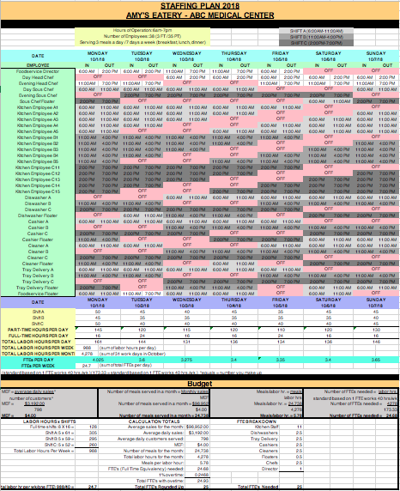
HUMAN RESOURCES:
PRODUCTIVITY/SCHEDULES - STAFFING

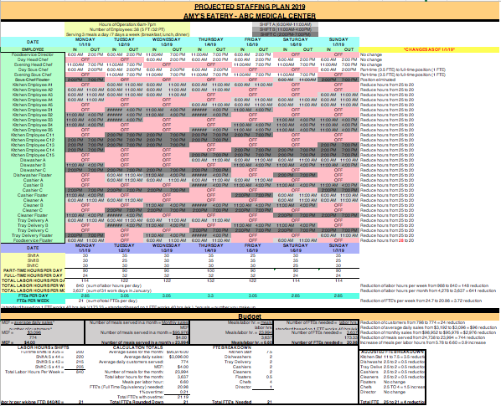
LABOR BUDGET

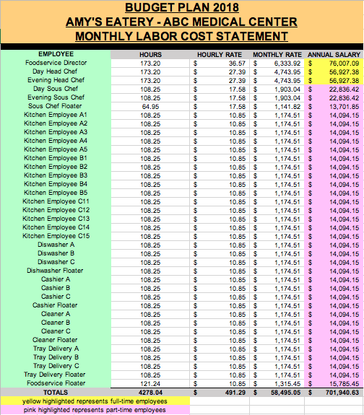
LABOR BUDGET

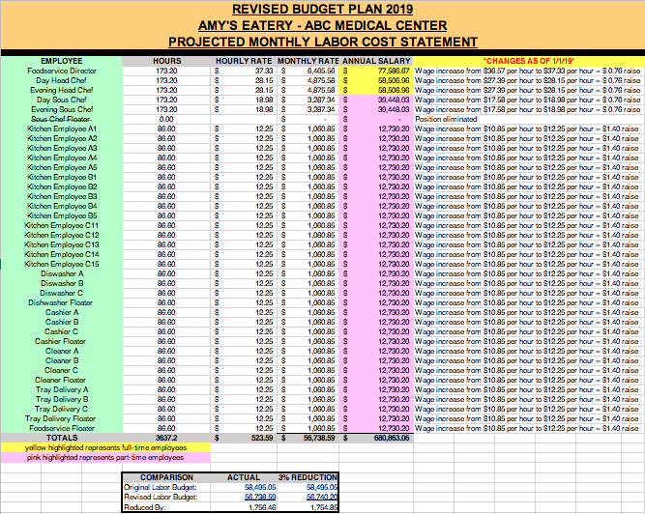
MARKETING PLAN

Marketing Opportunity Analysis:

To increase healthcare facility revenue, the food and hospitality services department at Amy’s Eatery will introduce a portable coffee café. It will strive to meet the needs, wants, and demands of the customers to obtain a service of quality and value while the facility ensures the ethics and philosophy of the facility are good and sound and as a result revenue is produced. The aroma of delicious breakfast items will fill the foyer area at ABC Medical Center with a unique layout and ambiance that is designed with an attractive seating area to converse and lounge.
Amy’s Coffee Café will offer healthy quality breakfast items and beverage options during the morning hours of 7AM - 11 AM. This will take place in the foyer area located in the corner section near the front entrance of the hospital. The food and hospitality service department will average between 1-2% in revenue per month. No additional staffing will be required. We will utilize the morning kitchen staff employees. These goods will provide a convenient, quick, and easy alternative to grab a morning meal on one’s way to their destination. The café will have the ability to offer quality goods for the “right” price, at the “right” place, and at the “right” time. The lobby venue will have a positive image and atmosphere to promote ABC Medical Center as a whole. Other additional strengths are that it can be a lucrative business focusing on high-quality food, quick service, low cost, strong branding awareness, located in a high traffic area, and well-trained employees with excellent customer service skills. Some weaknesses may be that this “goods service” plan will be oversaturated in the geographical area, customers would have already eaten before arriving, there is little recognition outside the hospital to promote the café, small menu, limited hours, and breakfast-only options.
Current Marketing Situation:
Breakfast and beverage availability are currently limited to opening hours of operation of 9 AM at Amy’s Eatery. The place of operation at Amy’s Eatery is located on the first floor to the far-right wing of the hospital. The only additional food service availability for sale of goods option is our vending machines. To remedy the inconvenience of location and hours of operation, this venture will allow a service that offers consistent, convenient, and reliable menu times at reasonable pricing compared to other competitors.
Competition we can encounter are local area coffee shops like Dunkin Donuts, Tim Horton’s, and Starbucks as well as fast-food chains such as McDonald’s, Burger King, and Bruegger’s Bagels. Since this will be run by Amy’s Eatery kitchen staff, it will be expedited and run by the foodservice floater and two kitchen “A” employees. Food will be prepared in the cafeteria kitchen and transported to the café area at 6:45 AM to set up for opening at 7 AM. Inventory will be based on prior cafeteria sales until a sales history is established.
Threats and Opportunity Analysis:
The possible threats our café may encounter could be that we invest in additional staffing and maintain the business premises even before we’ve made any money, changing prices of goods, or fluctuations in the economy. These ramifications could result in the dissolving of the portable café area and limiting revenue to the cafeteria and vending machines. The potential opportunities include but are not limited to high-speed Wi-Fi and new technology as a unique selling point (USP), offering an experience with soft music, dim lighting, and live plants that encompass a pleasant, inviting atmosphere which include; couches, coffee tables, end tables, tables, and chairs that are all centralized by a double-sided fireplace. Café and coffee sales will increase revenue by 15% in the next three years, create smaller versions of additional food stations throughout the hospital, BOGO deals, and loyalty customer cards.
SMART Goals:
The SMART goals that we plan to achieve within the next 2-3 years will be to create a portable coffee lounge and café at ABC Medical Center and increase profits of the foodservice department by 15% over the next three years with the objective to keep the increase in costs of the geographical area down by 3%. The second will be to host health and wellness fairs quarterly according to the seasons beginning May 2021 with an objective to gain more customers, promote upselling, and get customers to purchase more expensive and profitable items.
Marketing Strategy:
The target market will encompass staff and faculty employees, patient families and friends, outpatient customers, as well as external customers such as distributors and vendors. Our coffee café will offer a wide variety of goods such as assortments of freshly made whole grain muffins and bagels, oatmeal bowls, yogurt parfaits, wholesome breakfast bars, fresh fruit, a variety of breakfast sandwiches, juices, and gourmet coffees and teas. The average sales per month is currently $98,952. We are looking to increase our sales by 1-2% to give a revenue range of $989.52 - $1,979.04 per month. All items can either be purchased ala carte or sold as a meal option. We are promoting six different meal options consisting of one breakfast item, fresh fruit, and a drink for $6.00. We will increase public image by serving quality food and having exceptional customer service in an attractive, clean, and inviting environment. Amy’s Coffee Café will be branded and all paper products and logos promoting the café will have this as well as mandatory uniforms. The breakdown of costs per item/meal are as follows:
Ala Carte Menu Items | Cost
Breakfast Sandwiches | $3.00
Oatmeal Bowls | $3.00
Yogurt Parfaits | $3.00
Fresh Fruit Cup | $2.50
Bagels | $2.00
Breakfast Bars | $2.00
Muffins | $2.00
Juice | $1.50
Coffee/Tea | $1.00
Meal Option Items | Cost
Muffin, Fresh Fruit, Drink | $6.00
Oatmeal Bowl, Fresh Fruit, Drink | $6.00
Yogurt Parfait, Fresh Fruit, Drink | $6.00
Breakfast Sandwich, Fresh Fruit, Drink | $6.00
Bagel, Fresh Fruit, Drink | $6.00
Breakfast Bar, Fresh Fruit, Drink | $6.00

Action Plan:

Topic – obtain an estimated number of repeat customers to promote loyalty customer cards based on how often they make visits to the coffee café, how much do they typically spend, what is their favorite item, if they are full-time or part-time, and any recommendations or feedback.
Action | Completion Date | Person Responsible
Create monkey survey | January 1, 2019 | Ken Kaleta (IT)
Review survey | January 5, 2019 | Amber Lynn (Chef)
Send out survey | January 10, 2019 | Ken Kaleta (IT)
Obtain results/create spreadsheet | January 15, 2019 | Ken Kaleta (IT)
Analysis results | January 20, 2019 | Amy Buchanan (FSD)
Present results | January 25, 2019 | Amber Lynn (Chef)
Implement plan | January 30, 2019 | Alexis Brook (Café Staff)
Distribute loyalty cards | February 1, 2019 | Alexis Brook (Café Staff)

Controls:

To know if the coffee café will be a profitable foodservice venture, a separate budget projection spreadsheet will be implemented, determining daily, weekly, and monthly sales based on types of products sold, highest and lowest selling times, pricing of each item and gross vs. net sales. In order to achieve the above goals, a POS program will be installed in remote computers having access to this impertinent information to access profit and loss margins in order to sustain the success of the café.

