NFS 111 Applied Management in Dietetics December 8, 2017 “The Giving Garden” Final Draft

BUSINESS PLAN

INTRODUCTION

The name of our organization is “The Giving Garden”. This project involves building and maintaining a greenhouse and outdoor garden at Buffalo State College. The college will participate in maintaining the greenhouse and garden through a collaboration between the Health, Nutrition and Dietetics Department, the Health and Wellness Department, Chartwells (Buffalo State Dining Services), and Milligan’s Food Pantry. Milligan's Food Pantry is Buffalo State's on-campus food pantry where students in need can receive nonperishable items. Our purpose is to supplement the existing food pantry with fresh produce items. Additionally, the Giving Garden will host health and wellness fairs to promote healthy habits such as increasing the awareness of nutritious eating and the benefits of incorporating exercise into our busy schedules. The food/nutrition service provided by our organization is to grow fresh fruits and vegetables for the purpose of increasing accessibility of fresh produce for any Buffalo State college student with food insecurity as well as providing an educational component to increase awareness of nutritious meals, the concept of farm to table such as eating within the seasons, and striving to be a locavore. Milligan’s Food Pantry website will add the Giving Garden to their existing link “Eating Healthy on a Budget” which will include several topics such as recipe ideas and information about the foods we grow. Our target audience is any Buffalo State college student with food insecurity.

MISSION STATEMENT
Our mission is to provide Buffalo State college students who are experiencing food insecurity the means to obtain fresh produce to supplement and help nourish their bodies in order to live active, healthy lives while focusing on their education. Not having enough food or proper nutrition impacts a student’s ability to focus, study, and succeed. The Giving Garden is committed to providing education on nutrition and food preparation, promote sustainable gardening practices, connect people to nature and local foods, and to build a healthier community one seed at a time
ORGANIZATION CULTURE
The culture of the Giving Garden will be organic with the characteristics of being informal, flexible, evolving, and where employees feel interconnected. It will be a combination of both centralized and decentralized. Decision making will occur at the level of the people who are most directly affected and have the most intimate knowledge about the problem. Our organization will make initial decisions and pass them to lower levels of implementation. The organization will be a combination of classical and contemporary style management. The classical approach will encompass Systematic Management-Integration concepts into operation such as, seasonal changes and planting procedures. In the contemporary approach, we will use systems theory which is a managed system that changes inputs into outputs that ideally meet the organization’s needs for goods (fresh produce) and services (serving our students). The Giving Gardens’ supply of fresh produce will depend upon the needs of students with food insecurities. The size of our organization will start out small with around 30-50 staff, students, and volunteers and with time gradually become bigger while continuing to stay local. Our core values are to treat everyone with respect and equality, be open to change and flexibility, have an open mind and heart, strive for farm to table practices by eating within the seasons, encourage being a locavore, and to build a sense of community. The level of management our organization will have consists of the following:
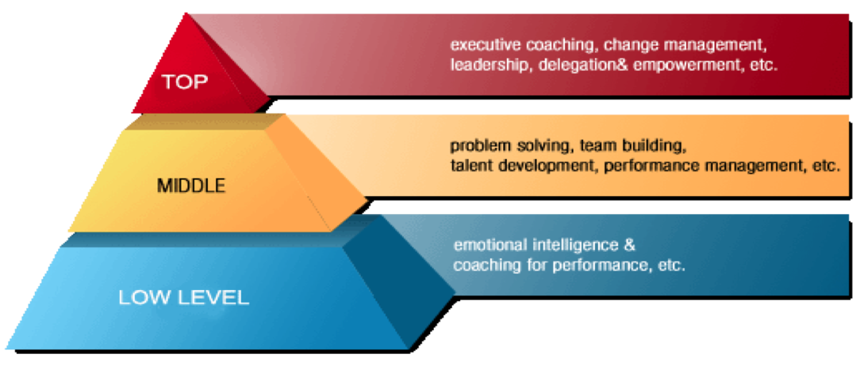
SMART GOALS
Two SMART goals that we plan to achieve within the next 3-5 years will to be create a greenhouse and garden at Buffalo State College and provide fresh produce to Milligan’s Food Pantry by January 2021. The objective is to involve Milligan’s Food Pantry, Chartwells, the Health, Nutrition and Dietetics Department, the Health and Wellness Department, and college students in the planning and running of this organization. The second will be to host health and wellness fairs quarterly according to the seasons beginning May 2021 with an objective to require dietetic students to participate in volunteerism by running at least one event per year.
MANAGEMENT
A traditional manager will oversee our organization based on a systematic management approach. The traditional manger will be able to observe and give out new task objectives to the employees. This can be challenging as a manager because in doing so, the manager might want to know the employee’s strengths and weaknesses. It is important that we know this about our employees so that the team can work effectively and efficiently to achieve organizational goals.
SWOT ANALYSIS
We will conduct a SWOT analysis for our organization and perceive our results to be the following: Our strengths will consist of having the organization run with the help from volunteers making the work load lighter with many hands. Volunteers are also great to have on the team because they are not part of our overhead cost for the organization. Some weaknesses we foresee would be that there has to be an upkeep process to make sure crops are being properly cared for. Secondly, volunteers are not guaranteed and might not be reliable. The biggest opportunities we see is becoming more involved in the local community at the same time being able to provide food for those in need. Possible threats we may encounter could be damage to crops from weather and animal pests or wondering where funding is coming from and is it continual?
ORGANIZATIONAL CHART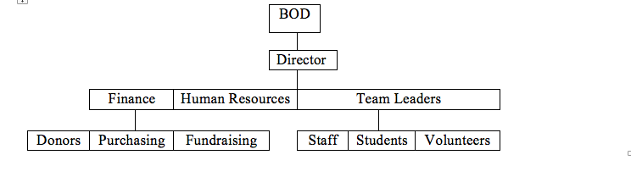
SOCIAL RESPONSIBILITY
We will demonstrate social responsibility by teaching about the benefits of fresh produce as well as letting everyone try new foods. This will improve nutrition education for Buffalo State college students. This will be a great method of outreach to gain more support. This is a responsibility that contributes to low food insecurity for students.
RECRUITMENT AND TRAINING
We will recruit new employees through each department and student email at the college. There will be two hiring categories; one through work study and the other direct hire. Upper management will set up job interviews in order to gain staff, students, and volunteers for maintaining the garden and servicing customers as well as the business aspect of the organization. Employees should be encouraged to promote the organization and use word of mouth to suggest the opportunity. Team leaders will train its employees by developing policies and procedures, daily responsibilities, tasks, and expectations. Monthly meetings will take place will all members to ensure workflow and safety is concurrent within the workplace. There will not be any formal orientation program. We will cultivate a diverse workforce by encouraging commuters, on-campus students, and support from staff and faculty. We encourage and welcome anyone to become a volunteer!
LEADERSHIP
Characteristics that our organization's leader will demonstrate consist of being able to have and uphold high standards for the organization. The second is to establish a set of norms that involve supporting and trusting one another. The last characteristic is to be purposeful with the organization and show ambition for it, always looking to improve the organization.
EMPLOYEE MOTIVATION
Our staff employees are rewarded by monetary compensation. Top and middle managers are paid as well. Students will receive volunteer, community service, and/or internship opportunities. A student may also be hired through work study or direct hire; therefore, they will be paid and gain experience in their field. Volunteers will be motivated through altruism and social responsibility that give them a sense of belonging to our community here at Buffalo State College. An additional benefit to our volunteers may be to receive a limited amount of fresh produce at the end of the harvesting season.
COMMUNICATION
We will apply effective communication techniques such as channeling the information through e-mails, newsletters, fliers, and text messages. A second way will be to use face to face discussion, which is important in this type of project. Monthly meetings will be held to ensure all recent decisions are communicated.
PERFORMANCE STANDARD
One performance standard for our organization will be to develop staff with first aid training and kits. Managers are required to obtain CPR & Servsafe certification. It is emphasized to strive for an accident-free workplace. Specific procedures will be used to avoid any accidents.
PERFORMANCE IMPROVEMENT
An area of our organization that will require improvement is to go from serving 10% of the current 30% of food insecurity students per year by Milligan’s Food Pantry to 20% by May 2023. This will be achieved by acquiring sponsors like Home Depot, Farmer’s Markets, and Nurseries for the project. We will also be contacting and making arrangements with the organization Habitat for Humanity. We plan to expand our inventory to diversify what foods are grown.
TEAM SUMMARY
When working on this project, we met as a group on Friday’s as well as doing some conference calls on Thursdays. We collaborated together by answering each question individually and then decided as a group by comparing and contrasting our ideas and coming up with an overall consensus. We worked well together as a team and critiqued one another’s ideas to form a creative and positive outcome. What worked well was the ability to meet on Fridays during normal class time. This was convenient since it was incorporated into our class schedules anyway. If there was any disagreement we talked out any confusion and we made sure that everyone in the group was satisfied before moving on. We also used Google Docs and Slides’ to work outside of classroom time along with a group text to allow us to communicate with one another.

