THE GIVING GARDEN PROJECT
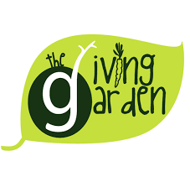
COMMUNITY NUTRITION PROGRAM BASED INTERVENTION PROPOSAL

AMY GERBER-BUCHANAN

Phone:585-820-1451
gerberal01@mail.buffalostate.edu
Life Cycle/Community Nutrition II (NFS 316)
Date: November 18, 2019

PREFACE

The impact of poverty, food insecurity, and poor nutrition has serious consequences for the health and well-being of children, adults, older adults, and families. Food deserts are especially concerning and may affect urban neighborhoods due to the lack of ready access to fresh, healthy, and affordable food. By addressing these complex challenges, we will provide an approach to a quicker, easier way to obtain fresh produce, create an increased awareness regarding the importance of healthy eating, as well as build skills and educational tools to improve the utilization of local foods. Food assistance programs, such as The Giving Garden, address barriers to accessing healthy foods. By transforming the way food is produced, sold, and consumed will ensure that families have access to nutritious food, whether it’s from their own garden, farmer’s market, or local grocery store.
- Demographics: The location where we will launch our intervention project is at 60 Caldwell Place located within Census Tract #123 in Lackawanna, just south of the city of Buffalo in the western part of New York State. This underserved area of concern is where we will launch our intervention project as identified in the charts below:
DEMOGRAPHIC FEATURES
Features | Census Tract # 123
County | Erie
City | Lackawanna
State | New York
Zip Code | 14218
Major Streets in the Area | Ridge Rd, Franklin Street, Electric Ave, South Park Ave, Kirby Ave, Center Street
School District | Lackawanna City School District
Bodies of Water | South Branch & Smoke Creek, Lake Erie (near tract)
Neighborhood | Lackawanna

ECONOMIC CHARACTERISTICS
Population | 2,963
Individual Income | $25,569 (Male $25,972; Female $23,750)
Gender | Male 1,578; Female 1,385
Median Age | 33.7
Marital Status | 2,269 (28.1% married; 4.8% widowed; 14.5% divorced; 1.8% separated; 50.8% never married)
Education Level Completed | 755 high school; some college or associates 809; bachelors 95; graduate 39
Disability | 308
Unemployment | 10.4%
Households | 1,309
Households w/ Food Stamps/SNAP | 430; 32.8%
Individuals Without Healthcare | 247
Ethnicity | 2,394 White; 225 Black; 220 Other;  124 Two or more races
Poverty Level | 22.5% (below 308; at or above 1,384)
Language Spoken | English 2,702; Spanish 133; Other Indo-European 144; Other 220

ENVIRONMENTAL HEALTH INDICATORS
Farmers Markets | 0
Supermarkets | 0; 1 Deli; 1 Express Mart
Convenient Stores | 3; 1 Double Tree Shop
Liquor Stores | 1; 3 Bars
Drug Stores | 1
Restaurants | 5
Public Transit | 10 (Bus Stops)
Library, Post Office, Bank, Police Station, Court House | 1 each  (3 ATM’s)
Parks | 1; 2 Baseball Fields, 1 Tennis Court
Family Support Services | 1 (Catholic Charities)
Healthcare Clinics | 0

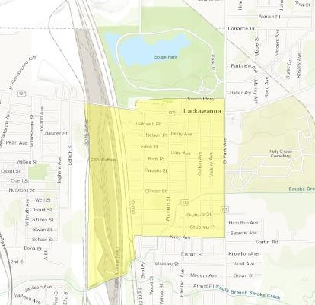
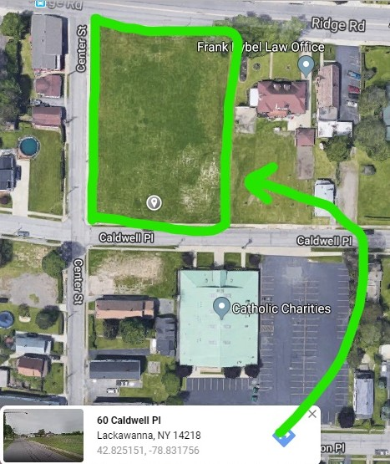
Census Tract #123 Project Location & Partnering Agency

Zip Codes in Lackawanna City of Lackawanna
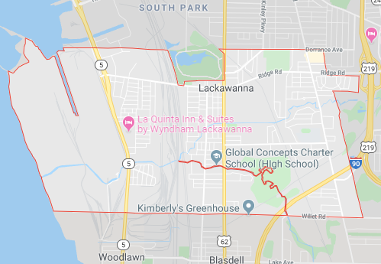
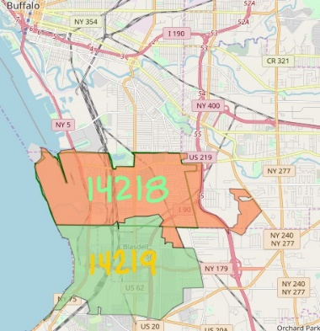

- Partnering Agency: The community agency, we will be partnering with is Catholic Charities of Buffalo, NY. Serving all Western New York since 1923, Catholic Charities serves those in need who are most vulnerable – children, adults, older adults and families. Their goal is, “optimum emotional, mental, and physical health for all”. As you can see from their Mission stated below, this is a perfect fit for what our intervention proposal needs to become sustainable for our community’s nutritional needs.

Mission

“Catholic Charities of Buffalo is a Catholic sponsored human service agency serving anyone in need in the eight counties of Western New York. Believing all persons are created by God, we empower individuals, children and families to achieve and maintain meaningful, healthy and productive lives. We advocate for those in need - particularly those who are poor and most vulnerable.”

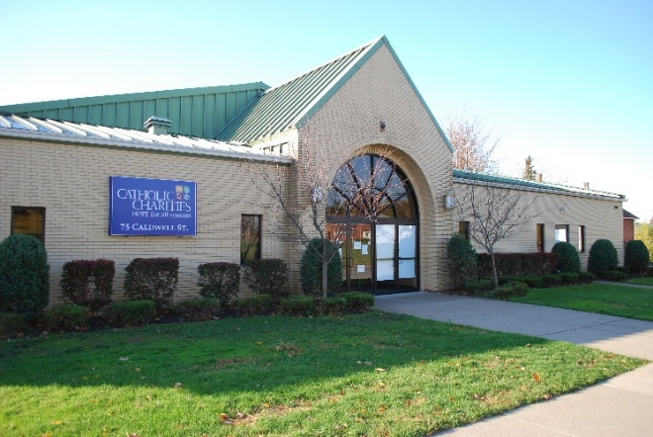
To carry out this mission, Catholic Charities seeks to engage its Catholic parishes, clergy, schools and youth, as well as the business community and all community members, in support of the Annual Appeal. Additional funding sources come from government contracts and grants, bequests, service fees, and other areas. Catholic Charities offers a wide range of services from basic needs such as food and housing, counseling, domestic violence, family and parent resources, immigration, multisystemic therapy, older adults, parish outreach and advocacy, school-based services, chemical dependency treatment and support, and workforce and education. They have opportunities to volunteer, donate, and host events as well as professional training and careers. We are excited to be partnering with such as inspiring and successful community agency that will support the Giving Garden’s vision and purpose. Catholic Charities maintains eight pantry and outreach centers in Western New York. The food pantry we will be working with is Russell J. Salvatore Food Pantry & Outreach located within Census Tract #123 at 75 Caldwell Place in Lackawanna. It is conveniently located across the street from a where we will bring to existence “The Giving Garden” project.

https://www.ccwny.org/location/browse?page=3

INTERVENTION PROPOSAL

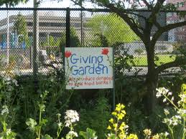
- Needs Statement: The title of our project is called “The Giving Garden”. The purpose of this community nutrition program-based intervention proposal is to decrease food disparities affecting poverty level families in Census Tract #123 of Lackawanna, NY and increase the importance and access of proper nutrition. The target population is low-income, poverty-level populations ranging from children to older adults who may have food insecurities. With our program, we want to help reach out to individuals and families who:
- Do not have the funds for fresh produce
- Do not have access to fresh produce
- Need to optimize their diet due to food shortages
- Desire to gain knowledge of gardening/food cultivation
Our Mission https://ycascadepeoplescenter.org/2013/05/06/cascade-p-patch-food-bank-signs/
“The Giving Garden is committed to providing individuals and families who are experiencing food insecurity the means to obtain fresh produce to supplement and help nourish their bodies in order to live active, healthy lives. The Giving Garden is committed to providing education on nutrition and food preparation, promote sustainable gardening practices, connect people to nature and local foods, and build a healthier community one seed at a time.”
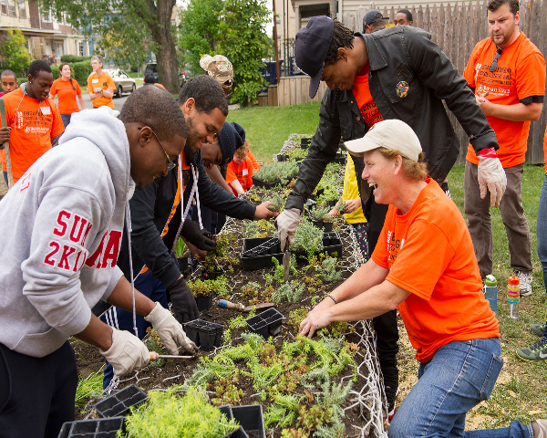
Our Core Values
Treat everyone with respect and equality.
Be open to change and flexibility.
Have an open mind and heart.
Strive for farm to table practices by eating within the seasons.
Encourage being a locavore.
Build a sense of community.
https://blog.suny.edu/2015/12/30-days-of-giving-2015-dare-to-care-day-at-buffalo-state/

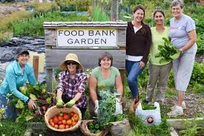
The amount of fast food establishments, convenience stores, and liquor stores within walking distance in Tract #123 are greater in number than supermarkets or farmer’s markets. These stores may have higher food prices, lower quality foods, and less variety than supermarkets or grocery stores making the challenge of healthy food choices that much more difficult. The ability to purchase fresh produce or other grocery items is more difficult due to the distance and availability. Many of the local convenience stores accept cards for SNAP and WIC. This allows low-income people or families to purchase these items in their locality. The 2019 poverty guidelines in the US is $12,490 per person. One-fourth of the individuals in the tract are at or below this poverty level and one-third of the households obtain SNAP benefits. The lack of resources to purchase healthier food items has a great impact on overall health. Based on the neighborhood features, the limiting factors to purchase fresh food and other healthy choices are significantly apparent. The increased number of convenience stores and fast food restaurants in the area allows for families to eat out of convenience which may contribute to obesity for all age groups. Many food choices in such establishments yield higher caloric counts and provide many food items that are not nutrient dense. Consumption of such food increases the risks of chronic diseases such as heart disease, obesity, and diabetes. The food choices in the area are high in sodium, sugars, and fats. Nutrition education is an important strategy for lowering negative impacts. When consumers are aware of the nutritional value of the food they buy, they are then able to make more quality choices. Strategies to lessen the negative health impacts would be to increase access to fresh produce in the area. This could be done by increasing the number of farmer’s markets and community gardens locally. This would allow for people in the area to have better options to buy quality foods.
https://www.google.com/search?q=food+bank+garden
- Goals and Objectives:
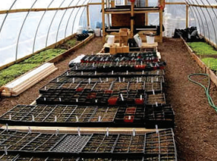
  - Goal
- Build a greenhouse and outdoor “giving” garden with a produce stand by spring of 2020 to help reduce the impact of food insecurity on families within Tract #123 by providing locally grown fresh produce.
  - Objectives https://caowny.org/wp-content/uploads/2017/03/CAO_CAgrO
- Partner with Russell J. Salvatore Food Pantry & Outreach at Catholic Charities to supplement the existing food pantry with fresh produce items.
- Acquire agreement with Kim’s Greenhouse and Blasdell Nursery to house gardening supplies and gleaning.
- Have local high school students volunteer at building one hoop house and two raised beds for giving garden as part of graduation requirements.
- Sell surplus food on Saturday mornings during summer months at produce stand to help offset the cost of maintaining the giving garden and greenhouse.
- Methods, Strategies and Program Design:

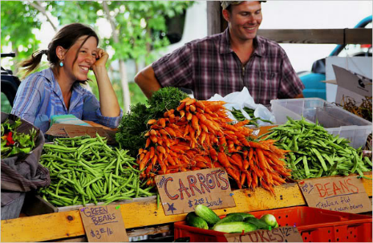
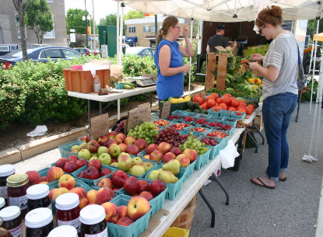
  - Floor Plan Set Up

Green House

Store Front
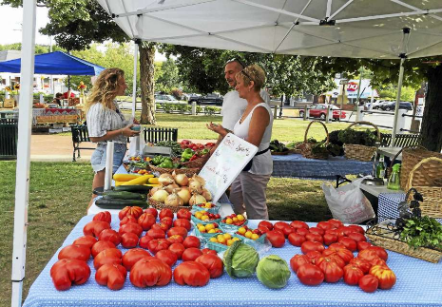
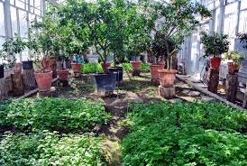

  - Organizational Chart

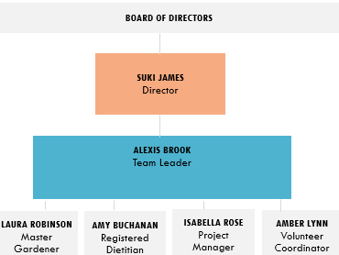

  - Logic Model
Purpose: The main objective of The Giving Garden is to provide food security for Tract #123 and increase access of produce with a quicker more affordable way to obtain fresh locally grown produce.

Inputs |  | Outputs  Activities Participation |  | Outcomes – Impact  Short-Term Medium-Term Long-Term

Tables  Table Clothes  Seeds  Fertilizer  Hoop House  Rototiller  Raised Beds  Money Box  Gardening Tools  Hoses  Access to Water  Tents  Fruit/Veggie Baskets  Plastic Bins  Plastic Bags  Markers  Signage  Scale  Volunteers  Staff  Advertising  Vouchers  Partnerships  Volunteers  Fencing |  | Build hoop house and raised beds  Rototill plot  Obtain seeds  Plant garden  Put up fence  Create signs  Maintain garden  Set up tents and tables  Sell produce at stand  Donate to foodbank | Pick and bag produce  Deliver food to Food Bank to be distributed to families in need  Host health fairs  Conduct gardening workshops  Provide nutrition education to families  Volunteers help in garden |  | Families receive fresh produce  Sell surplus of produce at stand  Volunteers receive fresh produce vouchers when they volunteer  Track amount of produce donated by method of weighing | Families learn about the benefits of fresh produce  Families gain skills on gardening  Families gain nutrition education  Giving garden maintains program throughout the summer season  Participation increase 10% | Families are more apt to create their own gardens  Families participate in volunteering in garden  Families create recipes from fresh produce  Reduced rate of food insecurity within tract #123 by 15%  Gleaning opportunities

Planned Work Intended Result
  - GANNT Chart

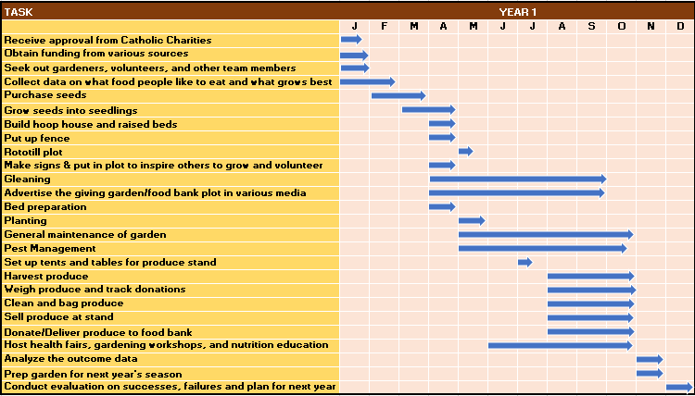
- Evaluation:

  - The Giving Garden will assess accomplishments by using the “process evaluation” method:
- Record of vouchers given each time participants volunteer
- Weigh and track donations
- Track growth production and outcome of the gardens’ produce
- Total sales in produce surplus sold
- Evaluate progress of intervention and make changes/improvements necessary
- Assess quality of gardening techniques and types of plants grown

  - The Giving Garden will use the following tools to evaluate the impact of the project:
- Household income, food consumption, and expenditure surveys
- Food frequency questionnaire regarding dietary intake
- Household hunger scale
- Anthropometry indicators
- Experience-based food insecurity measurement scales
- Household Dietary Diversity Score - Measuring household food access
- IPC (Integrated Food Security Phase Classification)

- Project Budget:

  - The total cost of the giving garden project is approximately $30,000.00. Every item listed is critical to the success of the intervention proposal. When calculating and researching each item needed and the various sources to obtain them, we also keep in mind affordable ways to stay within the budget.
  - Budget Breakdown

DIRECT COSTS
EQUIPMENT | COST
Tables | $100.00
Rototiller | $300.00
Gardening Tools | $200.00
Hoop House | $170.00
Money Box | $15.00
Tents/Canopy | $80.00
Scale | $50.00
Fencing | $240.00
Hoses | $75.00
Raised Beds | $100.00
TOTAL | $1,330.00
SUPPLIES | COST
Table Clothes | $40.00
Seeds/Transplants | $100.00
Irrigation Supplies | $390.00
Water Test | $20.00
Fertilizer | $120.00
Plastic Bins | $50.00
Plastic Bags | $50.00
Signage | $80.00
Vouchers | $30.00
Produce Baskets | $40.00
TOTAL | $920.00
PERSONNEL | COST
Staff Salaries | $20,250.00
Volunteers | (donate time) $0.00
TOTAL | $20,250.00
INDIRECT COSTS
Office Space Rental | $7,050.00
Advertising | $275.00
Utilities (Water) | $150.00
Markers/Pens | $15.00
Paper | $10.00
TOTAL | $7,500.00
DATA COSTS
Data Collection | $300.00
TOTAL | $300.00
GRAND TOTAL $30,0000.00

Direct costs make up approximately 75% of the overall budget, totaling $22,500. Most of the supplies and equipment are initial start-up costs thus reducing the overall budget in the following years. We will be able to store the supplies and equipment to be reused every year, obtain various items from donations, and recycle several supplies. The indirect costs consist of 25% of the overall budget, totaling $7,500. Most of these fees are regulated by Catholic Charities. We anticipate covering 80% funding of the indirect costs through grants, fundraisers, private contributions, foundations, and contracts from local, state, and federal agencies. The data costs comprise 2.5% of the total budget. This data collection will be obtained by utilizing a data collection software program to best create the information we need to stay abreast of relevant and current information driven data. To keep our costs down, we will take advantage of starting from seeds instead of buying seedlings, obtain free seeds, plant starts, garden signs, reuse containers for seeding, obtain household recyclable items, use buckets for growing, make compost, and collect rainwater.
REFERENCES

- http://www.usa.com/14218-ny.htm
- https://caowny.org/cagro/
- https://www.cdc.gov/brfss/index.html
- http://www2.erie.gov/health/sites/www2.erie.gov.health/files/uploads/pdfs/cha.pdf
- https://www.google.com/maps/@42.8033665,-78.8275238,408m/data=!3m1!1e3
- https://factfinder.census.gov/
- https://www.ccwny.org
- https://aspe.hhs.gov/poverty-guidelines
- http://www.usa.com/erie-county-ny.htm
- https://www.healthypeople.gov/2020
- http://www.scielo.br/scielo.php?script=sci_arttext&pid=S1415-52732008000700003
- https://www.ncbi.nlm.nih.gov/pmc/articles/PMC3771133/

