What is it?  Heading 9  It involves consuming low carbohydrates, high fat, with moderate protein that is aimed at helping with the lose of weight.  It consists of a 4:1 ratio of fats to carbs plus protein with a reduced caloric intake of 25%.  Typical consumption of carbs while on the keto diet is between 20g–50g carbs per day.  It is an adjustment in the ratio of macronutrients consisting of:  5%-15% carbs  25%-35% protein  60%-75% fat  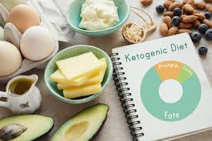 | HEALTH BENEFITS:  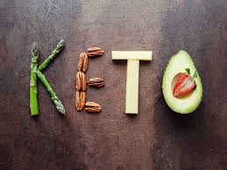  allows the body to maintain a low but healthy level of glucose.  widely used as a weight loss option for obesity.  bENEFICIAL FOR PEOPLE WITH TYPE 2 DIABETES, LOWERS RISK OF CANCER, AND NEUROLOGICAL DISORDERS.  Aids in REDUCING metabolic syndrome, ACID REFLUX, SEIZURES, HYPERTENSION, AND INFLAMMATION.  INCREASES INSULINS SENSITIVITY ENERGY LEVELS, AND APPETITE SATIETY.  IMPROVES MOOD, MENTAL CLARITY, AND HEART HEALTH. | The Ketogenic Diet  written by: amy buchanan  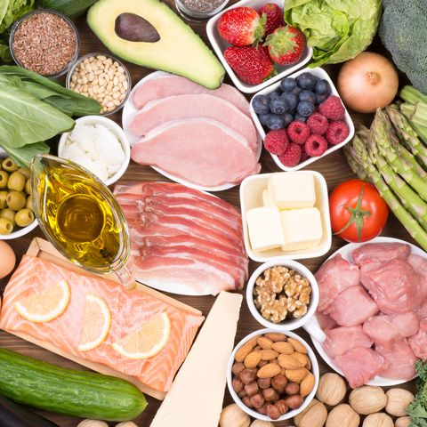
how does it work?  Heading 9  It aims at getting the body into a metabolic state called ketosis, where the drastic the drop in carbs, forces your body to burn fat for energy.  Ketosis is your body’s natural metabolic state.  When in ketosis, your body produces ketones out of fat and uses these ketones for energy instead of carbs.  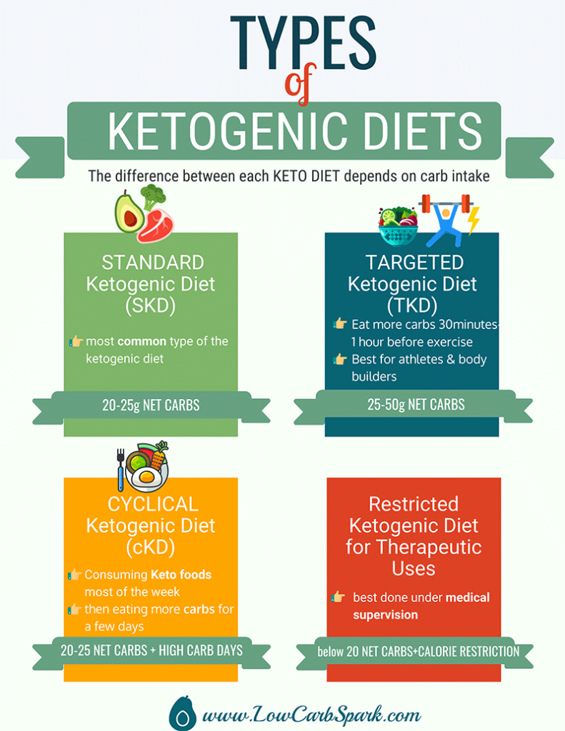 | what foods  are allowed?  Heading 9  A typical keto plate should be built on whole foods that consist of items like:  eggs, cheese, greek yogurt, butter, heavy cream, cottage cheese, bacon, avocados, nuts, seeds, low-carb vegetables such as cauliflower, mushrooms, spinach, tomatoes, brussel sprouts, and asparagus, coconut, flax, and olive oils, almond butter, fish and seafood, high quality poultry and grass-fed beef, berries, ghee, dark chocolate, and drinks such as water, bone broth, tea, and coffee.  what foods are RESTRICTED/LIMITED?  Heading 9  grains, beans, baked goods, ice cream, candy, soft drinks, breads, pastas, artificial sweeteners, “low fat” or “diet” foods, certain fruits, starchy vegetables, vegetable oils, processed foods, sweetened beverages, juices, milk, alcohol, and sugar. | getting into ketosis  Heading 9  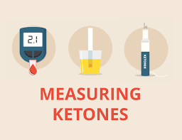  The keto diet focuses on consuming high-fat, moderate protein, and low carbohydrate intake. This forces your body to use fat for energy.  The best way to know if you are in ketosis is by blood testing for ketones. There are a variety of over-the-counter kits available to purchase such as urine and breath tests.  THE keto diet should be conducted under dietetic supervision and consideration given to supplementation with a multivitamin including trace minerals.  consult with an RD or primary care provider before starting.

